OS Lab # 05
Name: Sana Malik
Reg no: FA24-BSE-076
Semester/Section: BSE/5B

ps = Process Status
Shows information about running processes.
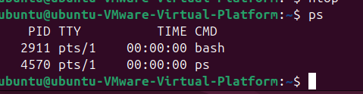

- ps → Process Status
- x → Include processes without a controlling terminal (background/system processes owned by you)
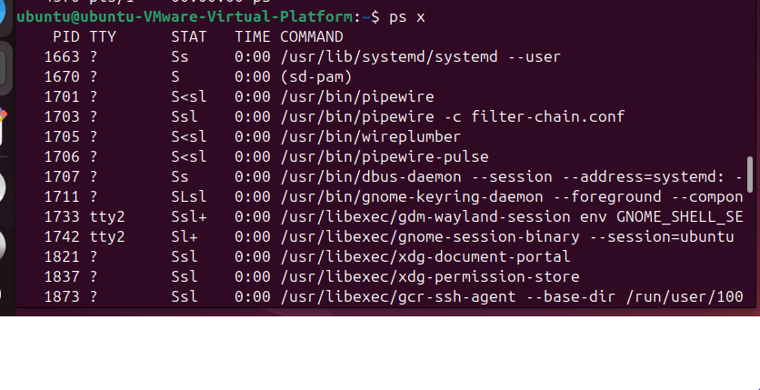
- ps → Process Status
- -f → Full-format listing (more details)
- -u → Show processes for a specific user
- ubuntu → The user whose processes you want to see
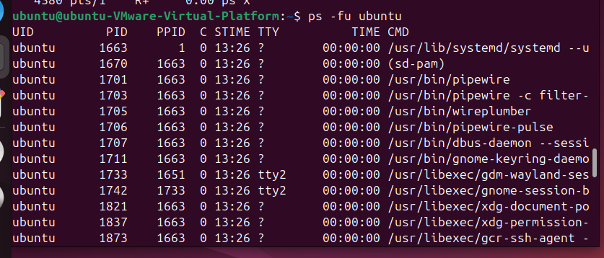
- ps → Process Status
- -f → Full-format listing
- -p → Select a process by PID
- 1602 → The process ID
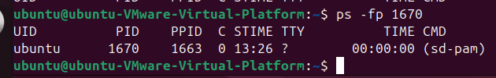

top = Table Of Processes
It is a real-time tool for monitoring running processes and system resources.
It shows:
- CPU usage → how much processor is being used
- Memory usage → RAM usage
- PID → process ID
- USER → process owner
- CPU% → CPU used by each process
- MEM% → RAM used by each process
- COMMAND → program/process name
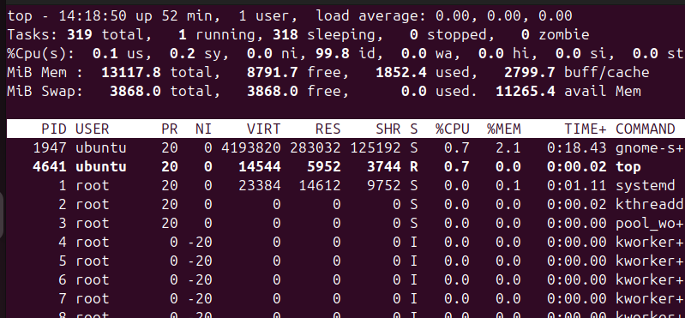

top lets us see and manage processes in real time.
pstree = Process Tree
It displays running processes in a tree/parent-child structure.
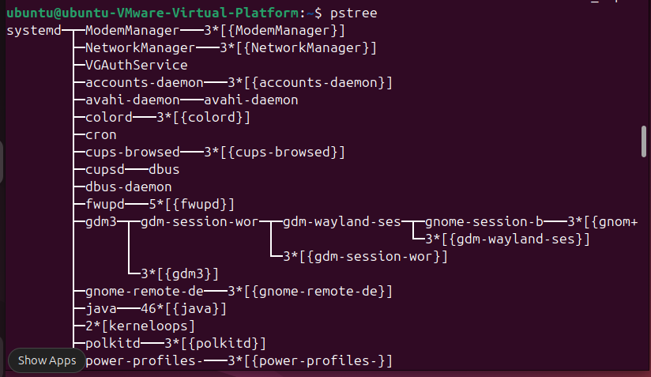
-p → shows the PID of each process.
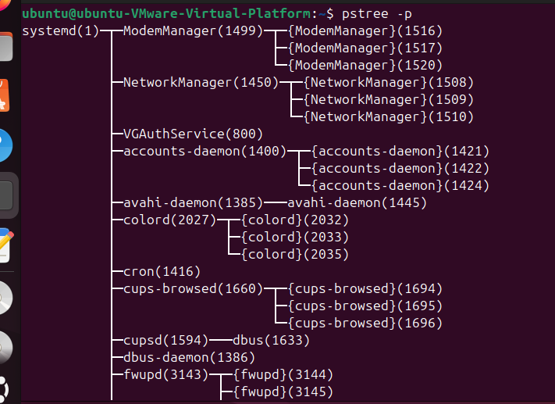

gedit is a text editor for Linux.
You use it to create and edit text files, including source-code files.
& tells Linux:
Run this command in the background.
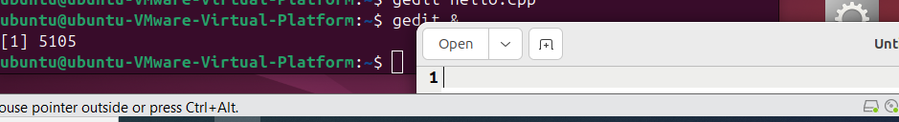

- firefox & → starts Firefox in the background
- jobs → shows background/stopped jobs of your current terminal

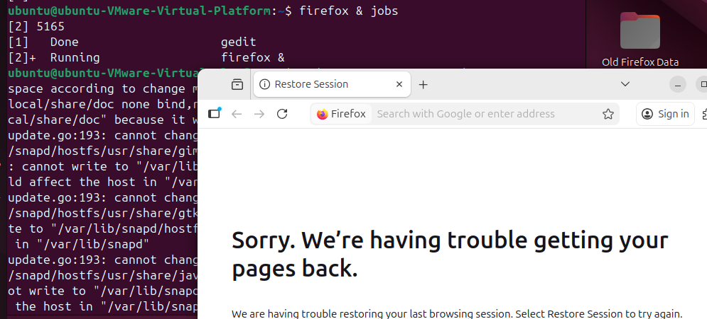

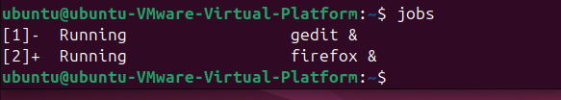

- fg → foreground
- %1 → job number 1
➡️ Brings job 1 from background to the foreground.
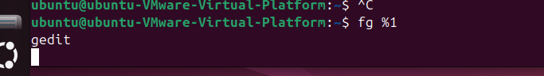
- kill → sends a termination signal
- 6408→ PID of the process
- ➡️ Requests process 6408 to terminate.
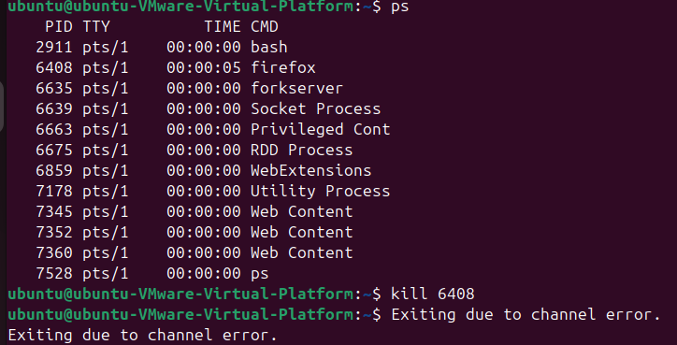

- kill → send a signal to a process
- -STOP → pause/stop the process
- 5008 → PID of the process
CONT = Continue
Continue running from where you stopped.
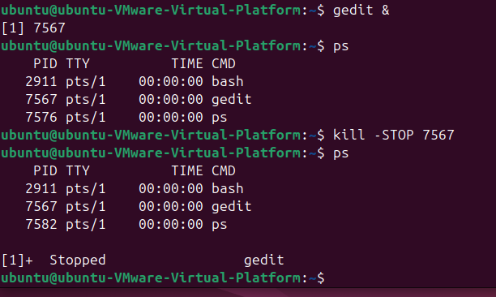

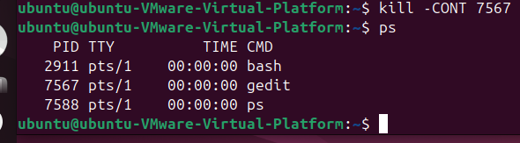

These commands are about process priority — deciding which processes get more or less CPU attention.
Linux has a nice value (NI):
Lower NI → higher CPU priority
Higher NI → lower CPU priority
ps -lf
Shows processes in long/full format.
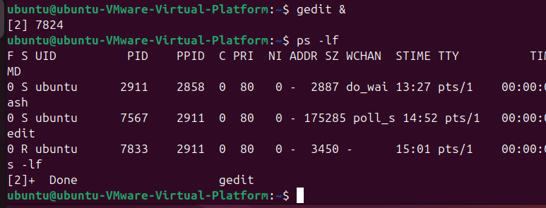

- nice → start a program with a chosen nice value
- -10 → nice value +10
- gedit → program to start
- & → run it in the background
Since 10 is higher than normal 0, it gets lower CPU priority.
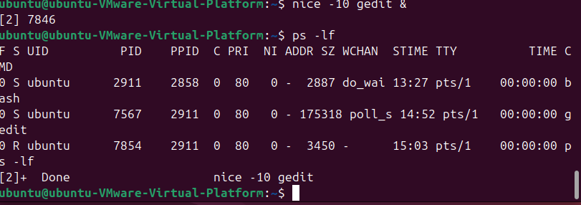

- sudo → run with administrator privileges
- renice → change the priority of an already-running process
- -n -12 → set nice value to -12
- -p 5161 → apply it to process PID 5161

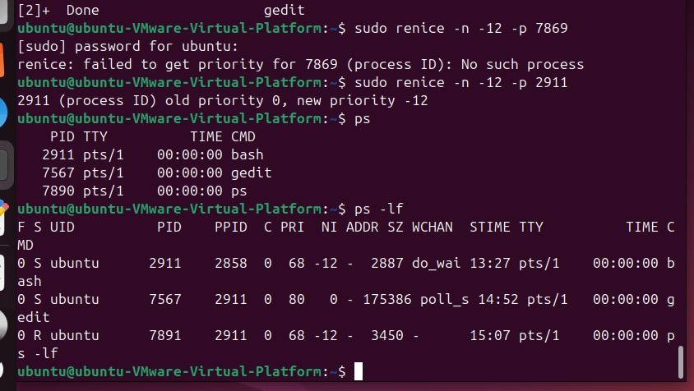

nice → set priority when STARTING a process
renice → change priority of an ALREADY RUNNING process

NI = -12 → higher priority
NI = 0 → normal
NI = +10 → lower priority

VM = Virtual Memory
stat = statistics
These are all Linux system monitoring commands, but each shows something a little different.
It shows statistics about:
- CPU
- RAM/memory
- processes
- swap
- disk I/O
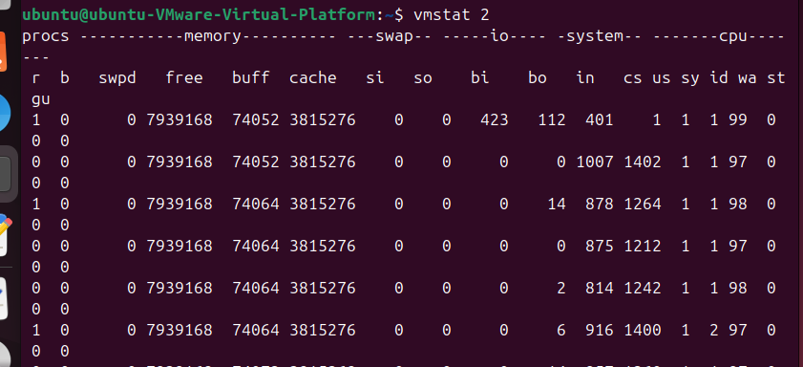

vmstat → detailed system statistics
xload → graphical load graph
tload → terminal load graph

Activity 1 — Process Monitoring in Linux
Ps ➡️ Shows processes running in your current terminal/shell.
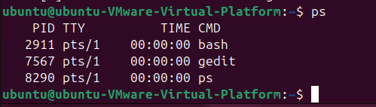

ps –e Shows all processes running on the system.
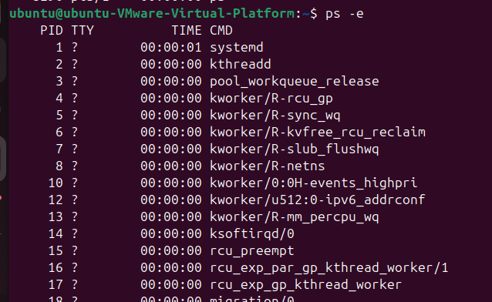

ps -fu $USER
-f = full format
➡️ -u = user's processes
➡️ $USER = your current username
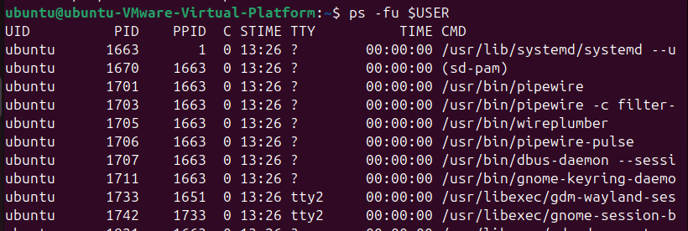

ps -fu Ubuntu
Shows all processes belonging to ubuntu in full format.
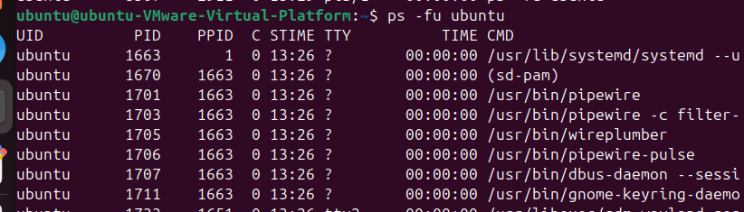

ps -fp 1
-p = specify PID
➡️ 1 = process ID 1
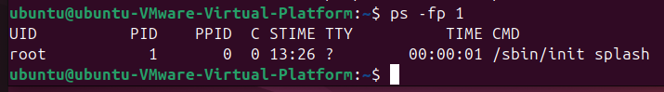

top -d 0.5
top = dynamic process monitor
➡️ -d 0.5 = refresh every 0.5 seconds
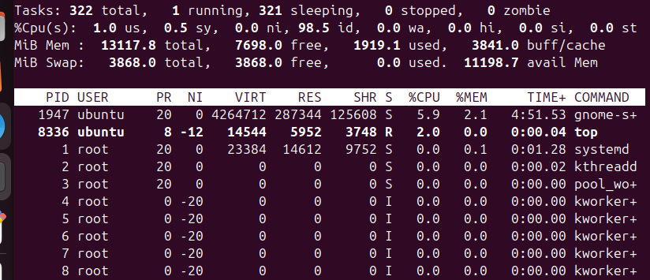
top -u ubuntu
Or by user ID:
top -u 999
Shows only processes belonging to that user.
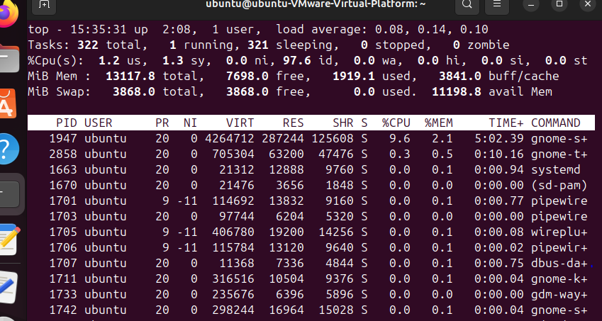

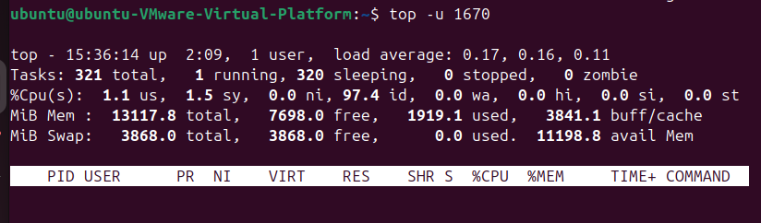

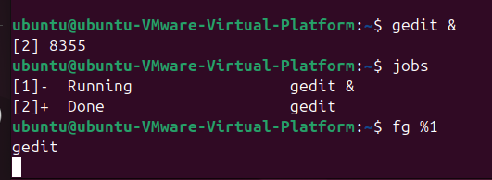

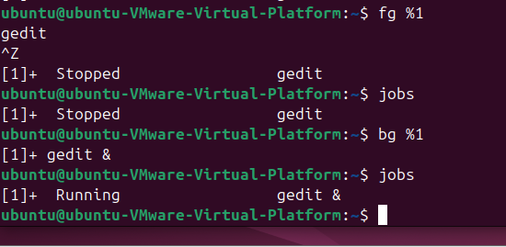

bg = background
➡️ %1 = job 1

& → start in background
jobs → show your shell's jobs
fg %1 → bring job 1 to foreground
Ctrl+Z → suspend foreground job
bg %1 → resume job 1 in background
top → dynamic process monitoring
ps → process listing

Activity 2 — Process Priority

_

